**Expno7:create a virtual machine**

**AIM:** Create a Virtual Machine with 1 CPU, 2GB RAM and 15GB storage disk using a Type 2 Virtualization Software.

**Material:**

● VM Workstation software.

● Configurations.

**Procedure:**

**Step 1:**

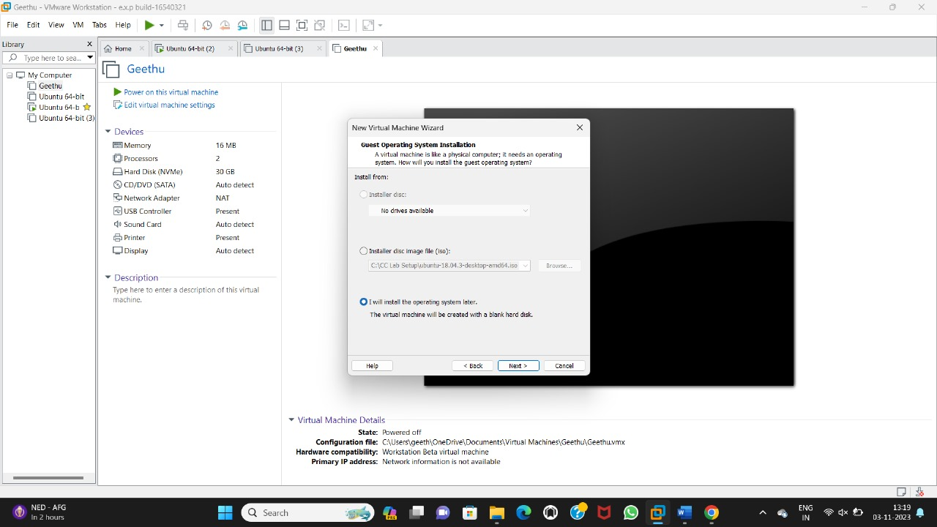

**Step 2:**

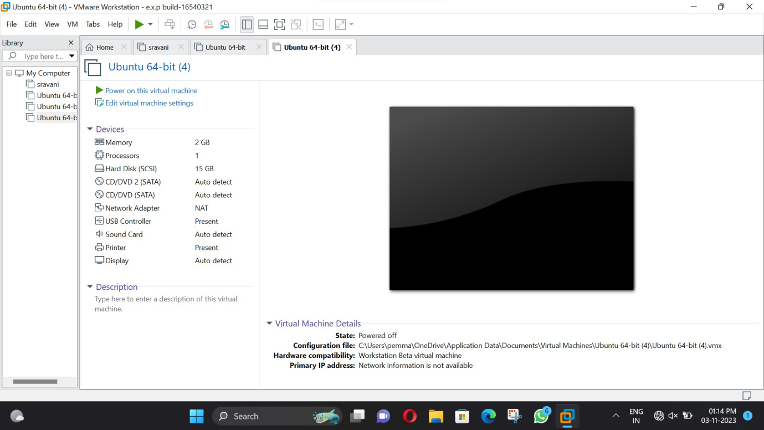

**Step 3:**

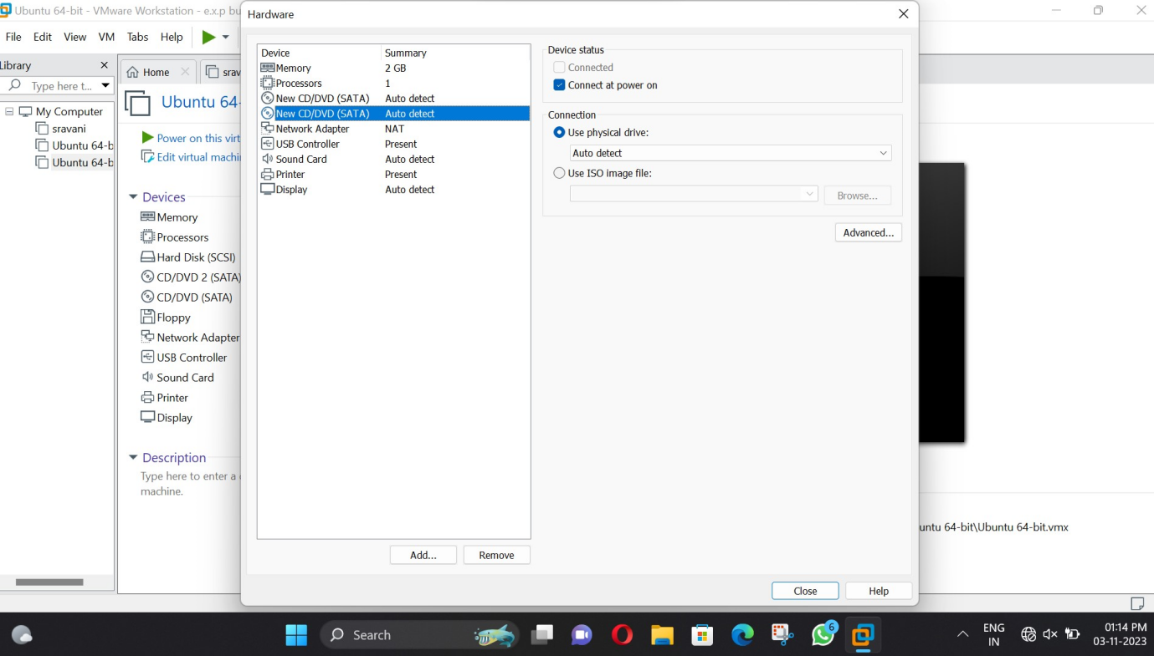

**Result:**

Successfully configure VM image with Virtual Machine with 1 CPU, 2GB RAM and 15GB storage disk using a Type 2 Virtualization Software.